VPI (Volume Pressure Index) Participation Scaling Model Algo

🧠 CORE IDEA (Numeric)
Item | Value | Meaning
Indicator | VPI | Net buy vs sell pressure
VPI Range | −1 to +1 | Strength of dominance
Lookback | 5 ticks (rolling) | Conviction over time
Quantity Scale | 0–100 | Participation sizing
Direction | ❌ Ignored | Quantity-only engine

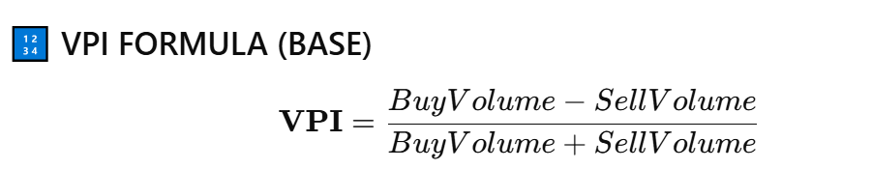📌 Important:
We compute VPI on rolling accumulated volume, not a single tick.

🟨 STAGE 1 — IDEA (VOLUME PRIMING)
🔢 Example Market Data (5 Ticks)
Tick | Buy Volume | Sell Volume
1 | 900 | 850
2 | 1,100 | 900
3 | 1,400 | 1,000
4 | 1,800 | 1,200
5 | 2,200 | 1,300

🔢 Rolling Volume Calculation
Metric | Value
Rolling Buy Volume | 900 + 1100 + 1400 + 1800 + 2200 = 7,400
Rolling Sell Volume | 850 + 900 + 1000 + 1200 + 1300 = 5,250

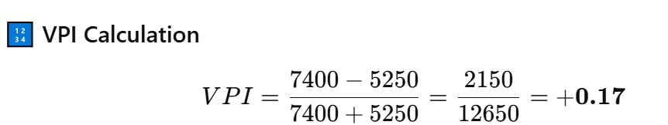
📋 IDEA STAGE TABLE
Parameter | Value | Algo Decision
VPI | +0.17 | ❌ Below threshold
|VPI| | 0.17 (< 0.20) | No conviction
Market State | Balanced | Stay flat
Quantity | 0 / 100 | ❌ No trade
State | WAIT | Observe
📌 Key Insight:
Volume exists, but no side is dominant enough.

🟩 STAGE 2 — CONVICTION BUILD-UP
🔢 New Incoming Tick
Tick | Buy | Sell
6 | 2,600 | 1,200
🔢 Updated Rolling Totals
Metric | Value
Rolling Buy | 7,400 + 2,600 = 10,000
Rolling Sell | 5,250 + 1,200 = 6,450

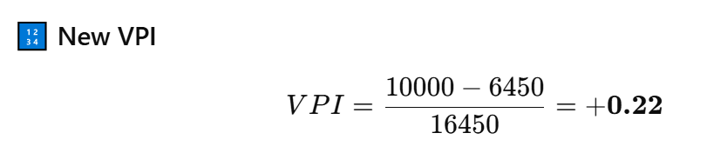
📋 CONVICTION TABLE
Parameter | Value | Algo Decision
VPI | +0.22 | Weak dominance
|VPI| | 0.22 | Above entry threshold
Market State | Weak | Start participation
Quantity | 25 / 100 | 🟡 Small size

🟩 STAGE 3 — CLEAR DOMINANCE
🔢 Further Accumulation
Tick | Buy | Sell
7 | 3,000 | 1,100
8 | 3,200 | 1,000

🔢 Rolling Totals
Metric | Value
Rolling Buy | 16,200
Rolling Sell | 8,550

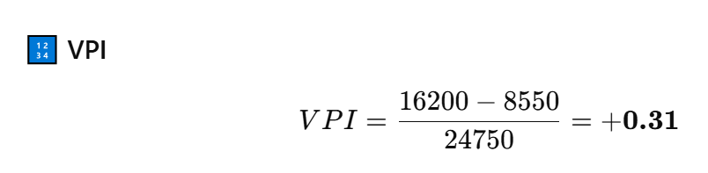
📋 DOMINANCE TABLE
|VPI| Range | Market State | Quantity Decision
0.20 – 0.39 | Weak dominance | 25 / 100
0.40 – 0.59 | Clear dominance | 50 / 100
0.60 – 0.79 | Strong control | 75 / 100
≥ 0.80 | Extreme control | 100 / 100
(Current case → approaching clear dominance)

🟩 STAGE 4 — STRONG CONTROL
🔢 Extreme Buy Pressure Example
Rolling Buy | Rolling Sell
25,000 | 4,000
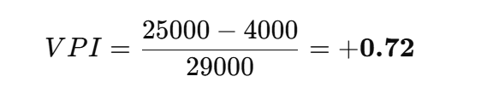
📋 STRONG CONTROL TABLE
Parameter | Value | Algo Decision
VPI | +0.72 | Strong dominance
|VPI| | 0.72 | High conviction
Quantity | 75 / 100 | 🚀 Aggressive
Action | Participate heavily

🟥 STAGE 5 — EXTREME CONTROL
🔢 Institutional Imbalance Case
Rolling Buy | Rolling Sell
30,000 | 2,000
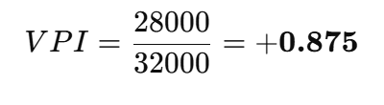
📋 EXTREME CONTROL TABLE
Parameter | Value | Algo Decision
VPI | +0.875 | Extreme dominance
Quantity | 100 / 100 | 🔥 Max conviction
State | Full participation

🟥 STAGE 6 — EXIT / REDUCTION LOGIC
📋 EXIT CONDITIONS (NUMERIC)
Condition | Example | Result
|VPI| < 0.20 | 0.72 → 0.15 | ❌ Exit
VPI collapses | +0.65 → +0.22 | Reduce size
VPI flips sign | +0.30 → −0.10 | Exit fully
Time decay | Flat VPI | Reduce

🧠 ONE-LINE MEMORY HOOK
VPI does not predict price.
It measures dominance.
Dominance decides quantity.

